Panaxia Global Reports: Panaxia Israel Continues to Grow
In the first half of 2020, the company exceeded its full-year revenues in 2019 with record revenues of 26.9 million, over four times the first half of last year.
Boasts 11 consecutive quarters of growth with record revenues of 14.8 million in the second quarter of 2020.
Switched from gross loss of 1.8 million in the second half of 2019 to gross profit of 1.6 million in the first half of 2020.
Increased gross profit by 195% over the first quarter of 2020.
(Tel-Aviv, August 30, 2020) The Israeli subsidiary of Panaxia Global, Panaxia Labs Israel Ltd. (Panaxia Israel, TASE: PNAX) the largest manufacturer of medical cannabis products in Israel, today reported the financial results for the second quarter and first half of 2020.
Dr. Dadi Segal, CEO of Panaxia Global, said, “The past six months have been the strongest in the company’s history, featuring the highest revenues in the sector, reflecting a growth rate of over four times over last year. Concurrently, the company continued to improve the gross profitability and reducing the bottom line losses, most of which are due to our massive preparations to export to Europe. The expanded activity in the first half of 2020 results mainly from increased demand for our quality products on behalf of Israeli patients and from the rapid evolution of the direct supply to the home model.
“The EU-GMP certification received last June from the EU authorities positions us at the forefront of the global cannabis industry alongside a host of international companies. Panaxia is currently the only cannabis company in Israel awarded with the prestigious EU-GMP certification. This development brings us closer to the important phase of initial export and sales to Europe by the end of 2020.”

Panaxia Israel: revenues in millions

Quarterly revenues, 2018-2020
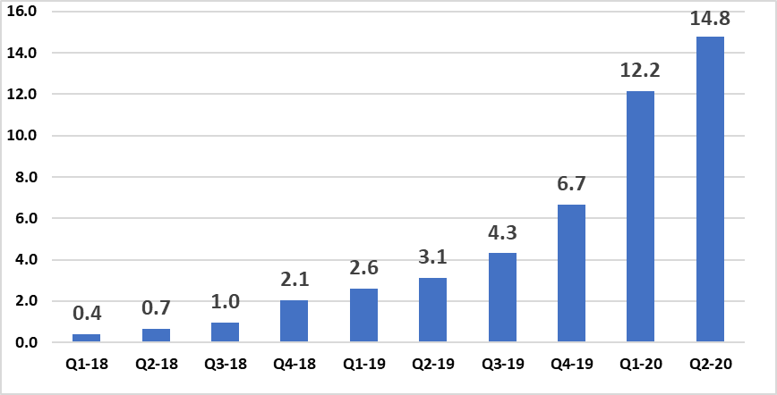

Financial results for the second quarter and first half of 2020
The company’s revenues in the second quarter of 2020 totaled a record of 14.8 million, an increase of 374%, more than four times revenues of 3.1 million in the same period of last year, and a 21%-increase over 12.2 million in the first quarter of 2020. The revenues reflect the growth of 11 consecutive quarters.
The company’s revenues in the first half of 2020 totaled 26.9 million, an increase of 370% or over four times the revenues of 5.7 million in the same period of last year, and 145% over 11 million in the second half of 2019.
The revenue growth is attributed to the growing business operations, which includes more patients as well as larger quantities of products manufactured and delivered by the company to patients’ homes as part of its home delivery service. In addition, the transition to sales under the new regulation provides the company with higher revenue per product unit.
The gross profit in the second quarter of 2020, under the new regulation, totaled 1.2 million, an increase of 195% compared with gross profit of 413 thousand in the previous quarter, and gross loss, under the previous regulation of 389 thousand in the same quarter of last year.
The gross profit in the first half of 2020 totaled 1.6 million, compared with a gross loss of 102 thousand in the same quarter of last year, under the previous regulation, and a gross loss of 1.8 million in the second half of 2019.
The improved profit and profitability during the quarter and the first six months of the year result from increased production and delivery to patients’ homes via home delivery service, and from leveraging the economy of scale. At the same time, the company incurred increased costs due to the need to comply with two standards, the Israeli IMC-GMP standard and the EU-GMP standard that the company was awarded in June 2020.
The company is also incurring higher variable costs due to increased production and higher cost of the finished products sold to the patients under the new regulation.
Cash and cash equivalents as of June 30, 2020, totaled 19.6 million, compared with 17.6 million as of March 31, 2020 and 14.3 million as of December 31, 219. The increase is due mainly to the completion of a capital round via private issuance of blocked stock and warrants at a total of 29 million. The capital round was led by MORE Investment House and another investor who asked to remain anonymous, majority shareholders, and existing investors, including the chair, Mr. Jonathan Kolber, CEO Dr. Dadi Segal, Mr. Ran Nussbaum, and others. The amounts quoted are net of the loan repaid to the parent company.
About Panaxia Israel
Panaxia Labs Israel, Ltd. is a publicly-traded company at TASE (TASE: PNAX). It is the largest Israeli manufacturer and home-delivery distributor of medical cannabis products, and the first to have received the approval of the Israeli Ministry of Health for the manufacturing of medicinal cannabis-based pharmaceuticals (under the IMC-GMP directive) as well as EU-GMP standard certification required for commercial production and export of medical cannabis and its products to Europe. The company manufactures over 30 hemp-based medicinal products and has accumulated a broad foundation of clinical experience based on tens of thousands of patients.
Panaxia is a subsidiary of the Segal Pharma Group, owned by the Segal family and founded over forty years ago. The company manufactures over 600 different pharmaceutical products that are distributed in over 40 countries worldwide. Panaxia Labs Israel is a subsidiary of Panaxia Pharmaceutical Industries, co-founded by Dr. Dadi Segal, Dr. Eran Goldberg, and Adv. Assi Rotbart as the cannabis division of the Segal Pharma Group. A sister subsidiary, Panaxia US, manufactures in North America over 60 hemp-based medicinal products, including sublingual tablets, lozenges, oils, and inhalators designed for treating conditions such as PTSD, cancer, chronic pain, epilepsy, anorexia, burns, and many other ailments. Panaxia Group has over 150 employees, who also conduct all of its clinical trials.
The Segal Pharma Group additionally owns Luminera Derm, manufacturer of injectable dermal fillers, and Tree of Life Pharma, manufacturer of over-the-counter drugs. For more information, visit the Panaxia website at https://panaxia.co.il/
For more information:
Noa Leviel
Lnoa@ibh.co.il

